**5 Hormone-balancing Superfoods & Recipes**

I grew up in South East Asia where women suffer few hormonal imbalances: they get pregnant easily, have no difficulty losing weight after pregnancy, struggle with little depression and anxiety, and slide into menopause with a sense of grace and deeper wisdom. Thyroid conditions have historically not been a pandemic and adrenal fatigue is unknown to most Asian women.

This is in stark contrast to the realities of Western women. The culture we grew up in taught us to believe that women and hormones are synonymous with being crazy, fat, tired, having no control and going on birth control pills to “manage it all.”

In today’s article I will explain how food can help you find that sacred balance each woman deserves to experience.

Hormonal problems are a sign of an imbalance. Do you know a person who is balanced and has weight, depression and fatigue issues? The answer is probably “no.” When in balance, wonderful things start to happen.

I want to show you how you can start this journey by adding a few foods to your arsenal of tools to help rebalance your hormones. Just to be clear: there is no one food that will reverse a hormonal imbalance. The suggestions below are great starting points.

To gain a deeper understanding of the food and hormone connection, I recommend you join me for a free online workshop on March 12th called, “How to Use Food to Rebalance Your Hormones.” Registration is here: [your affiliate link goes here]

**Thyroid – Brazil nuts**

If you have a thyroid condition, it is very likely (like 90% likely) that you have Hashimoto’s disease, which is the autoimmune version of hypothyroidism. Interestingly, in most cases of hypothyroidism and Hashimoto’s disease, it’s not the thyroid that needs to be looked after but the immune system (since Hashimoto’s is an autoimmune condition). One way to know whether you have Hashimoto’s is to test for thyroid peroxidase antibodies (that also go by TPOab).

If the TPOab test result is high, an important mineral that can help bring down the TPO antibodies is selenium.

Selenium plays a key role in thyroid and autoimmune health because it protects thyroid cells from oxidative damage by forming selenoproteins. This extra protection helps to bring down the TPO antibodies ([medical reference](http://www.ncbi.nlm.nih.gov/pubmed/23046013)). Selenium also acts as catalyst for converting the inactive T4 hormone to the biologically active T3 hormone.

The Brazil nut is the food that is highest in selenium. Three organic Brazil nuts per day will give you the daily recommended dose of 200mg of selenium. You can incorporate them into your diet in a variety of ways (see the recipes down below). If you don’t tolerate nuts, you can take a selenium supplement.

**Adrenals – camu camu**

The adrenal glands hold the highest concentration of vitamin C in the body and they need an abundance of it to function well, especially when under stress. Being tasked with producing the stress hormone, cortisol, the adrenals are hard at work in most people’s lives.

Some symptoms of adrenal exhaustion are: feeling light-headed when getting up, craving salt, sugar, feeling exhausted in the mornings, experiencing crying spells, feeling tired but wired at night, and having black circles under the eyes.

You can, of course, take vitamin C in supplemental form, but you can easily find it in food as well. [This study](http://www.ncbi.nlm.nih.gov/pubmed/18922386) reports that camu camu has more powerful anti-oxidative and anti-inflammatory properties than vitamin C supplements.

Camu camu (*Myrciaria dubia*) is a Peruvian berry found in the Amazon rainforest. After the seeds from the camu berries are removed, the fruit is slow-dried and milled at a low temperature into a fine soluble powder.

Just ¼ of a teaspoon contains 220% of the vitamin C RDA. If you are suffering from adrenal exhaustion, I recommend going up to ½ teaspoon per day by adding it to your smoothies (see recipe below). Camu camu is great for anyone (not just for adrenal fatigue) as it also supports the immune system and helps the detoxification pathways.

**Menopause – maca root**

Maca root (*Lepidium meyenii*) originates from Peru and is traditionally used by indigenous Peruvians as a vital dietary supplement believed to have favorable effects on energy and mood, fertility, improving sexual desire and decreasing anxiety, to mention a few. As a radish, it is part of the cruciferous family that is renowned for its hormone-balancing qualities.

Research has shown that maca contains no plant hormones, unlike soy and black cohosh. Instead, as an adaptogen, it helps adjust the body’s hormonal levels according to age and gender. Numerous clinical studies such as [this one](http://www.ncbi.nlm.nih.gov/pubmed/23674952) have shown that maca alleviates menopausal symptoms such as hot flashes, forgetfulness, fatigue, moodiness, vaginal dryness and mood swings.

Can maca be used by used by menstruating women or women with estrogen dominance? The answer is: yes. Maca can nudge estrogen in the right direction by improving symptoms such as PMS, infertility, loss of sex drive and mood swings.

Because of its butterscotch flavor, it can be easily incorporated into many recipes, like the ones below. A word of caution: as much as many women report wonderful improvements from using maca, there are those who feel worse (fatigue, digestive issues, worse PMS). It is best to tune in to your body to determine if it is the right medicinal food for you. Always start with a low dose of ¼ teaspoon.

**Estrogen Dominance – broccoli sprouts**

Most women have experienced some form of estrogen dominance without even realizing it. Symptoms include PMS, endometriosis, water retention, cellulite, weight gain, moodiness and infertility. Estrogen dominance can also be responsible for thyroid nodules and cancer as well as breast lumps and breast cancer. It is believed that 90% of breast cancers are of non-genetic origin and estrogen dominance can be the leading cause.

This hormonal imbalance can happen due to the dominance of the antagonistic estrogen called estradiol (or E2) as compared to progesterone or the protective estrogen called estriol (or E3). Estrogen dominance can also happen when there is an excess of metabolized estrogen called hydroxyestrones (a simple blood test called 2:16 hydroxyestrone can confirm that).

One of my favorite go-to foods to rebalance the estrogens and nudge them in the right direction are broccoli sprouts.

They contain di-indolyl-methane (short form: DIM, also found as a supplement) which detoxifies us of estradiol. Broccoli sprouts also contain the highest amounts of sulforaphane, which has been linked by numerous studies [like this one](http://www.ncbi.nlm.nih.gov/pubmed/20388854) to not only prevent but also reverse breast cancer. Sulforaphane can also be found in smaller quantities in other cruciferous vegetables like kale, broccoli or cauliflower.

Depending on one’s health condition, studies have shown that ¼ cup to 1 cup of broccoli sprouts can create profound health improvement resulting from rebalancing estrogen dominance.

I recommend using them raw by adding to smoothies, wraps, salads or warm (not hot) soups. See recipes below for some cool ideas.

**PCOS – flax seed**

PCOS stands for polycystic ovarian syndrome, a condition that results from high testosterone levels in women, ovarian cysts and high sugar levels (high glucose, HA1C or insulin). Women with PCOS often cannot get pregnant, have irregular periods or no periods, experience overly oily hair and skin, acne, stubborn belly fat, excessive facial hair and frontal balding.

One of the best strategies for managing and reversing PCOS is a reduction of blood sugar levels by incorporating an abundance of proteins and fiber.

My choice of fiber is flax seed. Its benefits go beyond the fiber alone – freshly ground flax seed releases lignans that are essential in rebalancing the estrogen levels as well. Many women with PCOS also suffer from estrogen dominance (see above) so flax seed offers the double benefit: fiber to bring down the sugar levels and estrogen regulation.

**Nut Butter and Super Sprout Smoothie Recipes**

I would now love to share with you some recipes that would inspire you to add these foods to your daily life and see how your hormones start shifting.

As always, exercise caution when adding these potent therapeutic foods; start with small quantities and let your body tell you how it accepts the new food.

**Brazil Nut Butter**

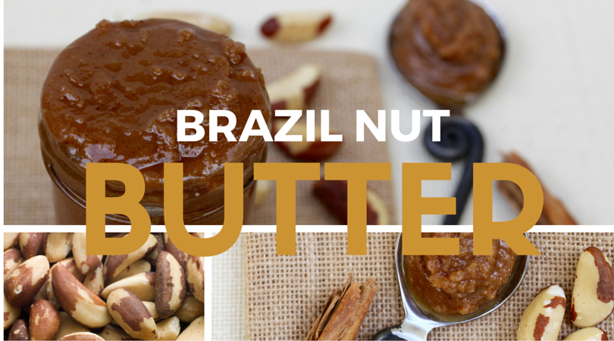

This nut butter can be generously spread on crackers, toast or used as a dip with chopped up vegetables (I used radishes here as they also support estrogen detoxification) or fruit (I had apples on hand today). I recommend soaking the nuts to improve their digestibility. If you tolerate nuts and have no time to soak and dry them, skip the initial steps and go to the blending instructions. Allow yourself to be creative and play with other nuts and seeds (sunflower and pumpkin seed butter is wonderful too) as well as spices like cardamom, cloves or lavender.

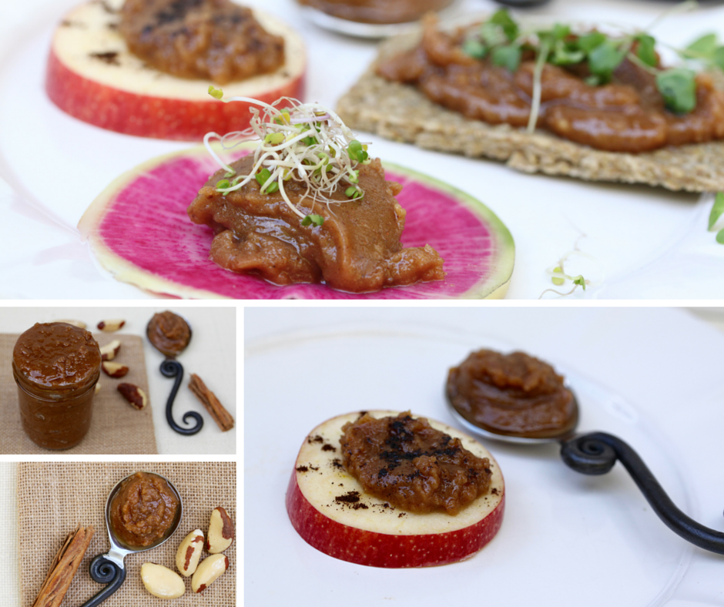

Serves: 25 servings (tablespoons)

Time to soak: 12 hours

Time to roast: 1 hour

Time to prepare: 15 minutes

Ingredients

2 cups organic Brazil nuts

¾ cup avocado oil

½ cup coconut butter

½ cup golden flax seed

⅓ cup maca root powder

1 tablespoon camu camu (buy on Amazon)

1 tablespoon ground cinnamon

1 tablespoon vanilla essence or powder

¼ teaspoon sea salt

Place the nuts in a large bowl, cover with filtered water and let them soak overnight, or 12 hours.

Preheat the oven to 200F, spread the nuts on a baking tray and slow-roast for about an hour or until they become slightly brown.

Cool off the nuts and place in a high-speed blender or food processor (I use Vitamix). Add all the remaining ingredients and blend on high for 3 to 4 minutes.

Transfer to an air-tight container and keep in the fridge for no longer than 2 weeks. You can also freeze the butter.

**Super Sprout Smoothie**

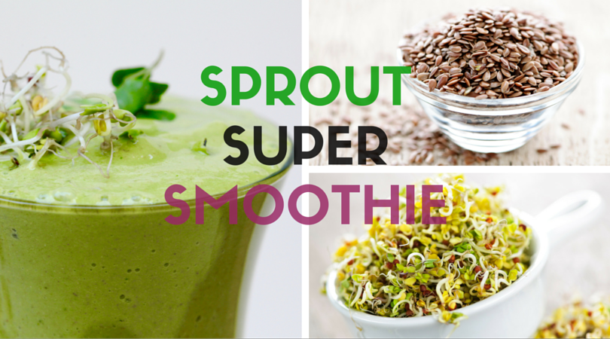

This recipe is a little different as it takes you on an unusual taste adventure to the land of a green savory smoothie. It is an energizing way to start the day with no sugar that will sustain you until lunch with no energy crushes. This smoothie is packed with the hormone-balancing superfoods: broccoli sprouts, flax seed, maca, Brazil nuts and camu camu and can be consumed by women of any hormonal imbalances.

Serves: 1

Time to prepare: 15 minutes

Ingredients

1½ cups water

½ avocado

½ cup broccoli sprouts

½ cup freshly chopped cilantro

4 Brazil nuts

3 tablespoons lemon juice

2 tablespoons flax seed

1 teaspoon maca root powder

½ teaspoon camu camu powder (get it on Amazon)

½ teaspoon ground fennel seed

½ teaspoon ground cumin

a generous pinch of salt

Place all the ingredients in the blender and blend until silky smooth.

**“How to Rebalance Your Hormones with Food” - FREE Online Cooking Workshop**

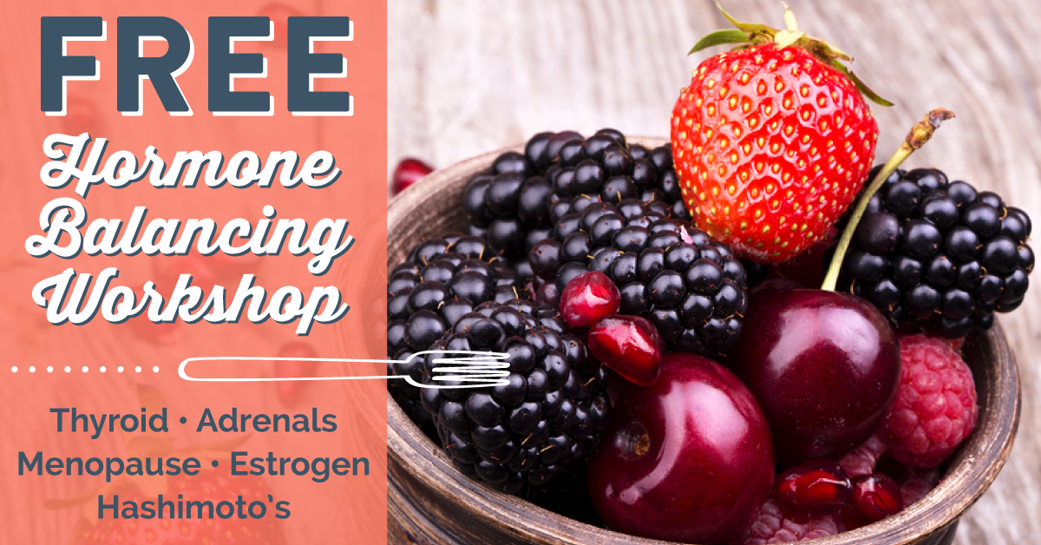

This article was contributed by Magdalena Wszelaki, a nutrition hormone expert, chef and author.

More hormone-balancing recipes and education is available at the free online workshop ***“How to Use Food to Rebalance Your Hormones”*** on March 12th. To get your spot, head over to [your affiliate link here].