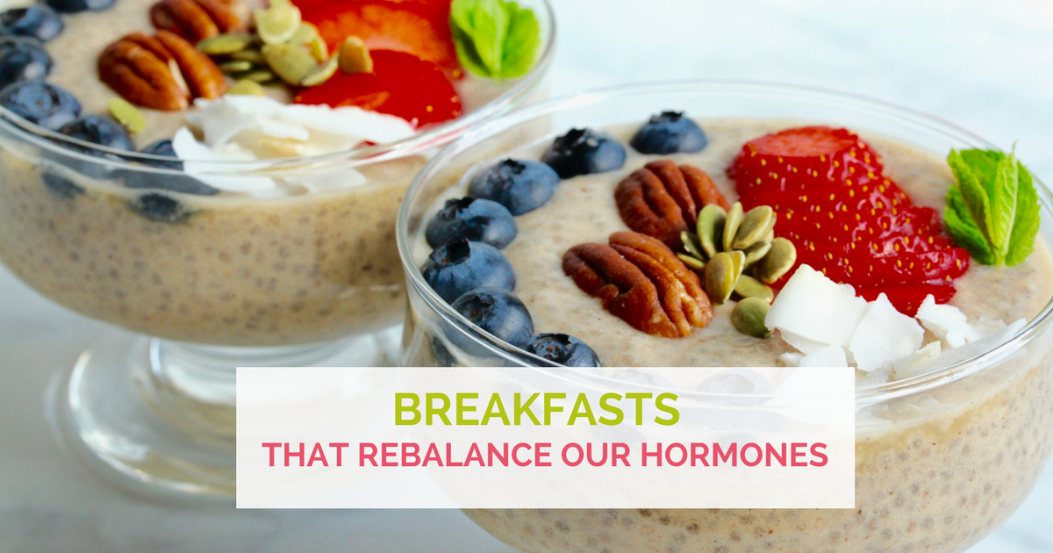

*(the above banner is FB compliant with only 20% text)*

**Breakfasts that rebalance our hormones**

It can be hard to imagine that the right kind of breakfast can be instrumental in rebalancing our hormones. Today you will learn why that is so and what breakfast can make such a difference.

The biggest challenge many of us face is feeling confused what to eat for breakfast. Many others think they are eating “healthily” but, in reality, they consumer a breakfasts that are so full of sugar that they might as well be called “morning desserts.”

We grew up with the belief that a good breakfast should contain large amounts of fruit, flavored yoghurt, grains, cereals, bars and oat meal.

Here is the problem: they are full of carbohydrates and sugars.

**Breakfast, sugar and hormones**

This creates three hormonal and metabolic problems:

1. Sugar addiction

When we consume too many carbohydrates and sugars for breakfast at, say 8am, we will then experience a sugar dip by 11am and feel hungry or shaky, moody and unfocused.

So what do we do? We reach out for something sweet again, like a bar, fruit or coffee to “rebalance our sugar level” and this way we end up only adding more sugar to our lives.

It’s not uncommon for many people to eat as much as 30 teaspoon-equivalent of sugar per day without even realizing it. One thing you can do today is to check the sugar content of the food you eat, especially for breakfast by using the simple conversion of 4 grams = 1 teaspoon of sugar.

As an example, Starbuck’s Vanilla Frappucino contains 69 grams of sugar which equals 17 teaspoons of sugar. Naked’s 15-oz orange juice will set you back with 42 grams (or over 10 teaspoons) and a Trader Joe’s Gluten Free Blueberry Muffin label states 24 grams or 6 teaspoons of sugar.

As you can see, it’s easy to fall in the sugar trap and become dependent on sugar.

1. Sugar lows and adrenal exhaustion

The second problem is that sugar addiction and sugar dips create STRESS to the body which calls for a release of cortisol by the adrenal glands to rebalance our sugar levels.

One of the functions of your adrenals (other than helping us deal with stress) is to rebalance our sugar levels.

As it is, many women suffer from compromised adrenal and these sugar dips weaken our adrenals even further.

Compromised adrenals have been linked to premature aging, dry skin, fatigue, coffee addiction (another skin-aging factor), weight gain, moodiness, frequent sickness and feeling depleted and de-motivated.

3. Breakfast and sleep connection

Many women note that their carbohydrate-rich breakfasts and sugar dips are big contributors to their insomnia, poor sleep and waking in the middle of the night. That’s not surprising – we often experience compromised sleep due to sugar level dips and cortisol spikes which is what keeps us awake or wakes us up in the middle of the night.

Their sleep typically improves with a change of breakfast, more on that below.

**What is a good breakfast?**

OK, so what do you do?

In today’s article, there are tips that will help you stop craving sugar, help you feel grounded, focused, satiated, and they might help you achieve deep and restful sleep.

**Tip #1: PFF Breakfast**

PFF stands for “Protein, Fat and Fiber.”

Yes, this means we will be loading up our breakfasts with protein, fat and fiber. Why?

Because they will guarantee us no sugar dips, they will sustain our sugar levels so we don’t exhaust our adrenals and they will help us break our sugar habit (or addiction).

Proteins are also full of amino acids which are the building blocks on our hormones.

The sources of proteins in your breakfast could come from fish, beef, chicken, bison, lamb, tempeh (if you can tolerate soy), coconut butter but also from moderate amounts of pre-soaked nuts and seeds, if tolerated.

I know, it might sound a bit unusual to be talking about dinner food for breakfast, right?

If you think about it, all global cuisines have savory breakfasts – like the Turks would eat plenty of salami and cheese, the Chinese dim sum is fat and protein-heavy, a traditional Japanese breakfast would have some miso soup and fish which are also savory and rich in protein and fats.

**Tip #2: Real food only.**

Many people think of protein shakes and powders when they hear the word “protein” and “breakfast.”

Well, in this new approach to your breakfast, the focus is on using only real and fresh food, not processed foods like powders and shakes.

As humans we were designed to eat, metabolize and absorb real food and not food that can sit in a box for two years – like protein powders.

That’s not real food. That’s just great marketing and gimmicks that make us feel fearful that we can’t get the right nutrients from real food.

It might be hard to hear to put away your protein powder.

But, if you suffer from hormonal challenges, why not try something different for just the next three days and see how your body responds?

There are a couple of recipes at the end of this article for you to try, we hope you will give them a chance.

**What to expect?**

People who follow the PFF breakfast recommendations report massive improvements.

Many of them start losing weight, feel focused and grounded, their sugar addiction ends or lessens, the stop to binge, their energy returns, their skin clears of acne, eczema and dryness, they sleep better and many report less PMS and less hot flashes.

Is it not amazing? From a simple change like that?

So let’s get to work. Try the recipes below and let us know how they worked for you.

How did you feel after having them for a few days?

Are you craving sugar the same way?

How different is your skin now?

**PFF Recipe #1: Farmer Wife’s Breakfast**

A hearty and savory breakfast is a wonderful way to start the day feeling grounded and satisfied.

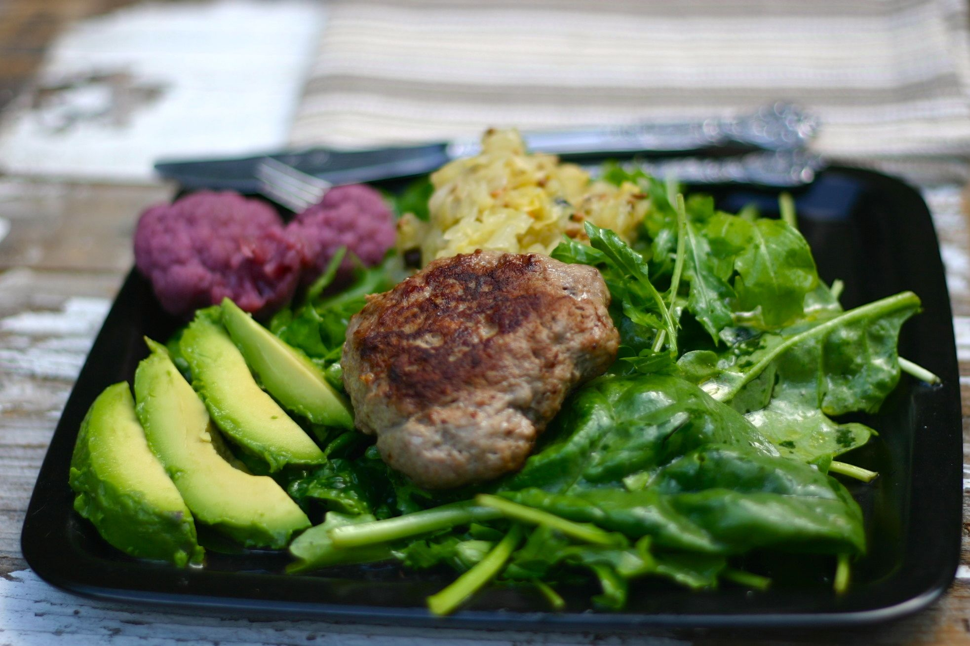

Healing foods in this recipe:

* Sauerkraut (probiotics, estrogen regulator)
* Mustard greens (nutrient-packed, estrogen regulator)
* Avocado (sugar-balancing, anti-inflammatory, nutritionally dense, anti-carcinogenic)
* Ghee (precursor for a precursor of steroid hormones like estrogen, progesterone, testosterone, cortisol and DHEA)

Time to make: 20 minutes

Serves: 6

Sausage (Serves 6)

•  1 lb of ground lamb (you can also used pork, beef or chicken or a combination of any of them)

•  1 tsp sea salt

•  2 tsps ground fennel seed

•  2 tbsps apple cider vinegar

•  2 tbsps coconut aminos

•  1 tbsp of ghee

Plate (for one)

•  1⁄2 avocado

•  handful of organic green mix (e.g. arugula, mizuna, baby kale, spinach)

•  1 cup of ferments (here: sauerkraut and cauliflower)

•  1 tbsp of olive oil

•  juice from 1⁄2 lemon or lime

•  pinch of sea salt

How to make

1. Mix all the sausage ingredients (except for the ghee), kneading them well. Taste and adjust flavor, as you like.
2. Shape the sausage to a desired shape– round and flat or long.
3. Heat up the skillet and add the ghee.
4. Add sausages and fry them for approximately 7

minutes on one side and 4 minutes on the other.

1. In a separate bowl, toss green salad mix with olive, lemon and salt until the leaves are well covered with the dressing.
2. Place greens on a large plate, then add the

sausage, avocado and ferments to the plate.

**PFF Recipe #2: Chocolate Cherry Smoothie**

This low-sugar breakfast recipe can easily be adapted to become a decadent snack or a healthy dessert. The fat from the avocado and coconut butter along with the protein from the hazelnuts and pumpkin seeds will help keep blood sugar levels stable.

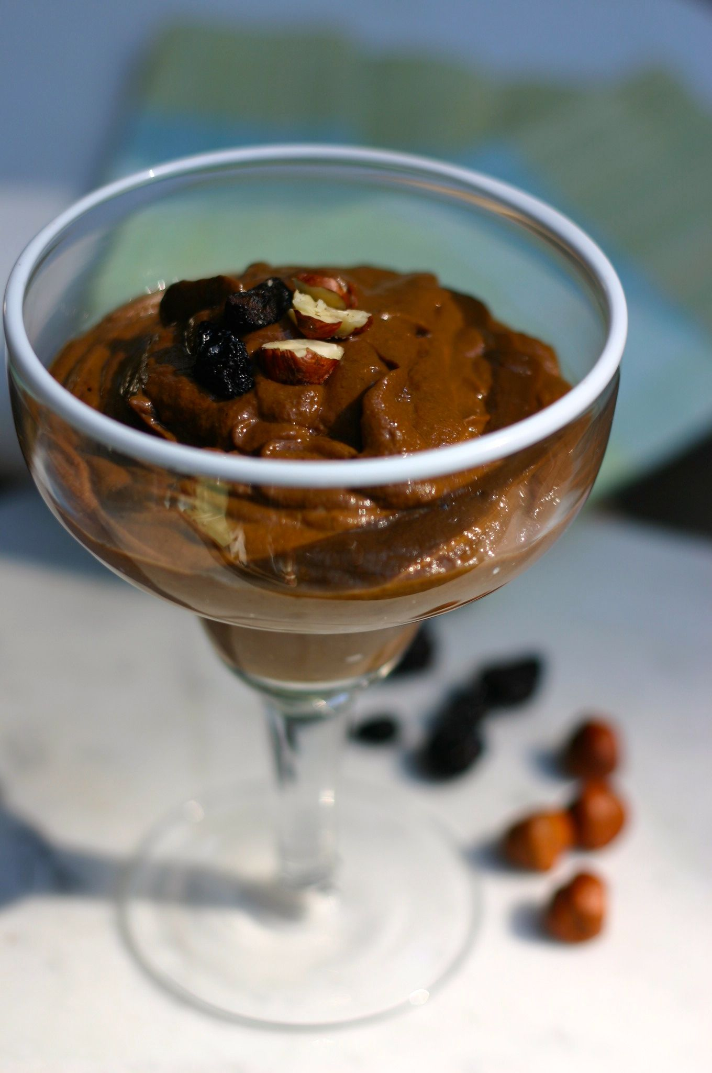

Healing foods:

* Cacao (magnesium, flavonoids as antioxidants, vitamin Bs and E)
* Avocado (sugar-balancing, anti-inflammatory, nutritionally dense, anti-carcinogenic)
* Coconut butter (supports plump skin, anti-bacterial, healthy fat for long term energy, high in fiber, precursor for many hormones)
* Pumpkin seed (high in magnesium, zinc, protein, fiber, anti-oxidant, anti-fungal, anti-viral)

Time to prepare: 10 minutes

Serves: 2 servings

Equipment: blender

Ingredients:

* 1 avocado
* 2 tbsp raw unsweetened cacao
* 1 tbsp coconut butter
* a handful of pumpkin seeds
* a handful of hazelnuts, pre-soaked overnight
* a handful of dry cherries, pre-soaked in hot water for 10 minutes (you can replace with goji berries too)
* 1 tsp vanilla extract
* 1 tsp lemon or lime juice
* 1⁄2 tsp cinnamon powder

How to make

Put all ingredients into the blender and blend until smooth.

This article was contributed by Magdalena Wszelaki, a nutrition coach, hormone specialist and a chef. She has a long history of hormonal challenges herself (from Hashimoto’s, adrenal exhaustion to estrogen dominance) which she has managed to reverse with the use of the right nutrition.

Magdalena is offering a free online workshop **“How to Use Food to Rebalance Your Hormones”** on October 24th, 2015. To reserve a free spot (limited seats), register at [your affiliate link here]

